SPRINT -1

|  |  |
| --- | --- |
| DATE | 21 October 2022 |
| TEAM ID | PNT2022TMID41312 |
| PROJECT NAME | AI-powered Nutrition Analyzer for Fitness Enthusiasts |

**AI-POWERED NUTRITION ANALYZER FOR FITNESS ENTHUSIASTS**

Food is essential for human life and has been the concern of many healthcare conventions. Nowadays new dietary assessment and nutrition analysis tools enable more opportunities to help people understand their daily eating habits, exploring nutrition patterns and maintain a healthy diet. Nutritional analysis is the process of determining the nutritional content of food. It is a vital part of analytical chemistry that provides information about the chemical composition, processing, quality control and contamination of food.

The main aim of the project is to building a model which is used for classifying the fruit depends on the different characteristics like colour, shape, texture etc. Here the user can capture the images of different fruits and then the image will be sent the trained model. The model analyses the image and detect the nutrition based on the fruits like (Sugar, Fibre, Protein, Calories, etc.).

**Technical Architecture:**

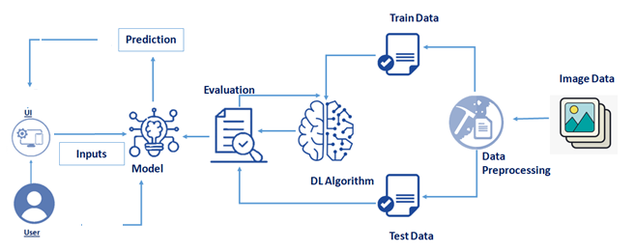

**PROJECT OBJECTIVES**

**By the end of this project you will:**

* know fundamental concepts and techniques of Convolutional Neural Network.
* gain a broad understanding of image data.
* Knowhow to pre-process/clean the data using different data preprocessing techniques.
* know how to build a web application using the Flask framework.

### PROJECT FLOW

* The user interacts with the UI (User Interface) and give the image as input.
* Then the input image is then pass to our flask application,
* And finally with the help of the model which we build we will classify the result and showcase it on the UI.

To accomplish this, we have to complete all the activities and tasks listed below

* **Data Collection.**
  + Collect the dataset or Create the dataset
* **Data Preprocessing.**
* Import the ImageDataGenerator library
* Configure ImageDataGenerator class
* ApplyImageDataGenerator functionality to Trainset and Testset

* **Model Building**
  + Import the model building Libraries
  + Initializing the model
  + Adding Input Layer
  + Adding Hidden Layer
  + Adding Output Layer
  + Configure the Learning Process
  + Training and testing the model
  + Save the Model
* **Application Building**
  + Create an HTML file
  + Build Python Code

PREREQUISITES FOR ARTIFICIAL INTELLIGENCE

# Hardware Specifications:

* Windows (minimum 10), Mac & Linux
* Ram - 4GB ( minimum)
* Hard Disk - 100GB (minimum)
* Processor - Intel i3 (minimum), Mac M1

# Software Specifications:

* Anaconda Navigator - <https://www.anaconda.com/products/distribution>
* Jupyter notebook.
* Google Colab - <https://colab.research.google.com/>
* Spyder / VS Code / Pycharm

# IBM:

* IBM Account Creation - <https://vimeo.com/742609168/1824d26a5b>(Follow this video for IBM Skill Build Account Creation)
* IBM Skill Build - <https://www.ibm.com/academic/home>
* Webmail - https://sg2plmcpnl492529.prod.sin2.secureserver.net:2096/
* IBM Cloud - <https://cloud.ibm.com/login>

### PROJECT STRUCTURE

Create a Project folder that contains files as shown below

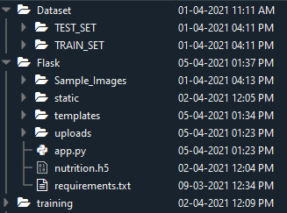

* Dataset folder contains the training and testing images for training our model.
* We are building a Flask Application that needs  HTML pages stored in the templates folder and a python script app.py for serverside scripting.
* we need the model which is saved and the saved model in this content is a nutrition.h5
* templates folder contains home.html, image.html, imageprediction.html pages.
* Statis folder had the css and js files which are necessary for styling the html page and for executing the actions.
* Uploads folder will have the uploaded images(which are already tested).
* Sample_images will have the images which are used to test or upload.
* Training folder contains the trained model file.